## 1. What command did you use to create a ROS package?

I created *two packages* using the following commands:

|  |
| --- |
| catkin_create_pkg project1_turtlesim rospy std_msgs geometry_msgs turtlesim |
| catkin_create_pkg lab3_turtlesim rospy std_msgs geometry_msgs turtlesim |

Since the project refers to **lab3_turtlesim**, I used it as the ROS interface. However, I developed the actual implementation in ***project1_turtlesim***. To ensure both packages reflect the same code, I created symbolic links from ***project1_turtlesim*** to point to the corresponding folders in **lab3_turtlesim**. This setup allows me to run the node using either package name, while maintaining a single folder of code.

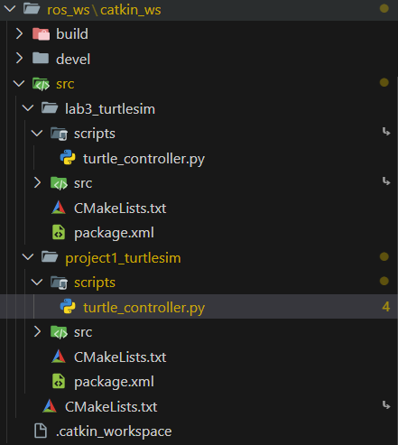

## 2. Explain why and how you used ROS messages in your program.

* ROS messages allow different parts of the system to communicate. In this case, we use them to send movement commands to the Turtle node.
* Using the help of geometry_msgs.msg.Twist Library I was able to Controll the Turtles Movement, Directions and Turning Angles.

## 3. Describe the steps to launch ROS, TurtleSim, and your ROS node simultaneously.

Since I was doing it in Docker these were the steps I followed

### Pre-Setup:

#### First, I Run the Docker Containers…

docker compose up -d

#### Then on EACH TERMINAL I Enter the Docker Container.

docker exec -it ros-melodic-container bash

### Terminal 1:

#### Then on EACH TERMINAL I Enter the Docker Container.

roscore

### Terminal 2:

#### Then on EACH TERMINAL I Enter the Docker Container.

rosrun turtlesim turtlesim_node

### Terminal 3:

#### Enter the ROS Catkin workspace Directory.

cd "/mnt/host/Desktop/Seneca_Class_Notes/Semester 2/AIG240 -Robotics/ros_ws/catkin_ws"

#### Sets Up the ROS Environment for Custom Packages (Not always required)

source devel/setup.bash

#### Launches the Custom Package (Python Script) as a ROS Node.

rosrun lab3_turtlesim turtle_controller.py turtle1

or

rosrun project1_turtlesim turtle_controller.py turtle1